
Practical Report
For IoT Practical

Darshan Ramjiyani (DSP)
DOCS, KSKV Kachchh University

- 5.10 – Simple Analog and Digital Input

- Arduino Code:

long warningThreshold = 1200;
long criticalThreshold = 1000;
const int batteryPin = 0;
const int ledPin = 13;
void setup()
{
pinMode(ledPin, OUTPUT);
}
void loop()
{
int val = analogRead(batteryPin);

if( val < (warningThreshold * 1023L)/5000)
flash(val) ;
}

void flash(int percent)
{
digitalWrite(ledPin, HIGH);
delay(percent + 1);
digitalWrite(ledPin, LOW);
delay(100 - percent );
}

- Output / Circuit Diagram:
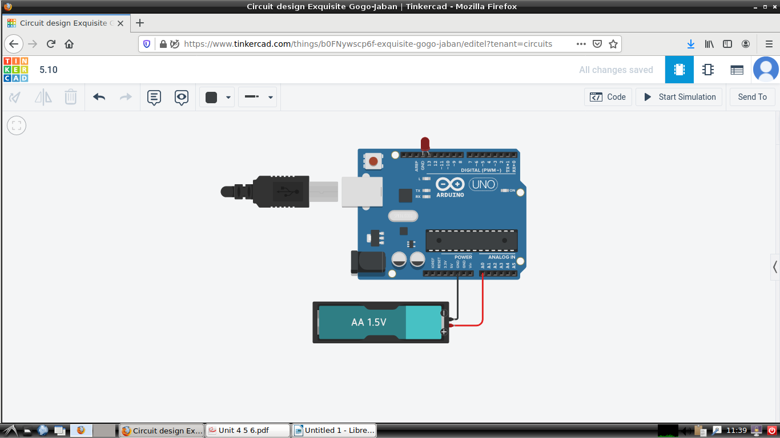
Darshan Ramjiyani

